Tool: Job Action Sheets for ICS

ICS Organizational Chart
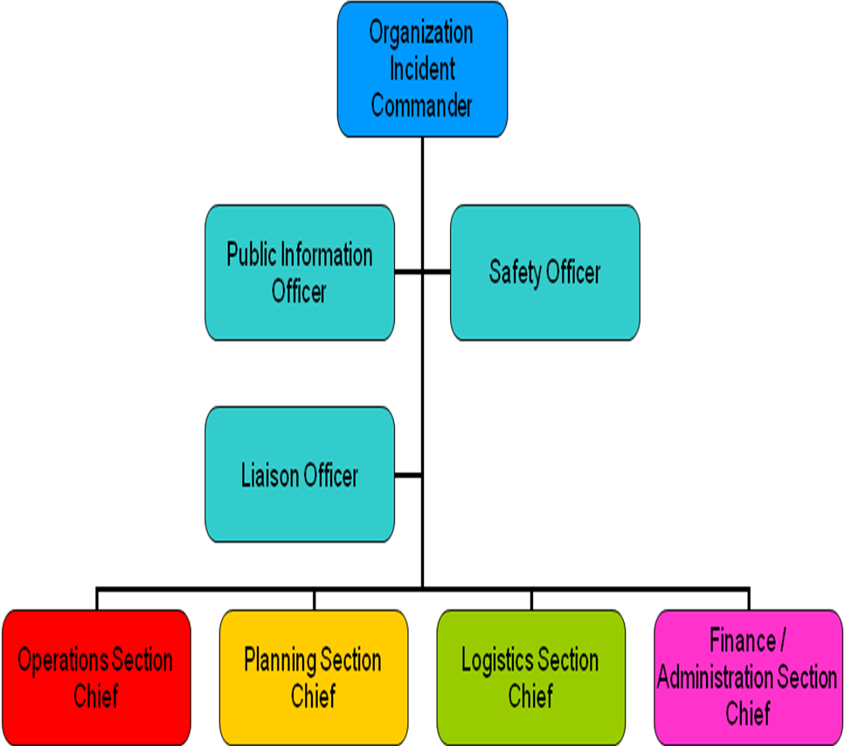

Tool: Job Action Sheets for ICS

Incident Commander (IC)
Reports to: Local Government Incident Commander
Mission: Give overall emergency response direction for the organization.
What to do Immediately:
- Read this entire Job Action Sheet.
- Get a full understanding of what is the emergency or disaster.
- Appoint your staff and team leaders (use your ICS Chart) as needed for this response; distribute their specific Job Action Sheets to them.
- Implement your plan to continue your normal services (if applicable).
- Work as a team to establish priorities or objectives for the response to the emergency.
- Contact relevant external agencies (like the local government or your neighboring partners).
What to do to Respond:
- Authorize resource allocation as needed or requested (use your team to help).
- Schedule routine meetings with your staff and team leaders to receive updates.
- Maintain contact with relevant agencies (like the local government or your neighboring partners).
For an Extended Response:
- Watch your staff for status and signs of stress and take care of any problems immediately.
- Provide rest periods for staff.
- Prepare updates as needed and give them to the local government incident commander.
- Prepare updates for your staff and clients.
- Plan for the possibility of extended response efforts.

Tool: Job Action Sheets for ICS

Operations Section Chief
Reports to: Incident Commander
Mission: Coordinate the implementation of priorities, goals, and objectives. Direct the preparation of specific emergency response plans and request resources as necessary.
What to do Immediately:
- Receive job and Job Action Sheet from your Incident Commander.
- Read this entire Job Action Sheet and review organizational chart.
- Get updated on the situation from the Incident Commander.
- Enlist the help of others to work under you during response efforts. Clearly define their role in helping you do your job so there is no confusion.
- Update your assistants on the situation and the response plan as you learn it from the Incident Commander.
- Identify and report any resources needed for the response effort to Liaison Officer and/or the Logistics Section Chief.
What to do to Respond:
- Brief the Incident Commander routinely on the status of the Operations Section. (How are your response efforts going?)
- Request resources as needed to help with your response effort.
For an Extended Response:
- Maintain documentation of all actions and decisions (this will help with continued response and recovery from the emergency).
- Watch all staff for signs of stress. Report any issues. Provide rest periods and relief for staff.
- Plan for the possibility of extended deployment.

Tool: Job Action Sheets for ICS

Planning Section Chief
Reports to: Incident Commander
Mission: Gather information, think ahead, make and revise actions for response efforts, and keep the team informed and functioning.
What to do Immediately:
- Receive job and Job Action Sheet from your Incident Commander.
- Read this entire Job Action Sheet and review organizational chart.
- Get updated on the situation from the Incident Commander.
- Enlist the help of others to work under you during response efforts. Clearly define their role in helping you do your job so there is no confusion.
- Update your assistants on the situation as you learn it from the Incident Commander.
- Work with the Operations Chief to determine how to meet the team’s priorities and objectives.
- Identify and establish access to resources as needed.
- Work with the Logistics Section Chief for technical support and supply needs.
- Collect, interpret, and synthesize information regarding status and response of incident and provide reports to the Incident Commander.
What to do to Respond:
- Assemble information from updated reports you receive from the other section chiefs.
For an Extended Response:
- Continue to receive updated reports from section chiefs.
- Maintain documentation of all actions and decisions (this will help with continued response and recovery from the emergency).
- Watch all staff for signs of stress. Report any issues. Provide rest periods and relief for staff.
- Prepare end of emergency report and present to Incident Commander or local government, as necessary.
- Plan for the possibility of extended deployment.

Tool: Job Action Sheets for ICS

Logistics Section Chief
Reports to: Incident Commander
Mission: Find, distribute, and store all necessary resources for the response effort. Act as a maintenance or facility supervisor.
What to do Immediately:
- Receive job and Job Action Sheet from your Incident Commander.
- Read this entire Job Action Sheet and review organizational chart.
- Get updated on the situation from the Incident Commander.
- Enlist the help of others to work under you during response efforts. Clearly define their role in helping you do your job so there is no confusion.
- Advise the Incident Commander on current logistical service and support status (especially when working with the local government or neighboring agencies).
What to do to Respond:
- Update Logistics Section staff of new developments and receive status reports.
- Secure areas as needed to limit unauthorized personnel access.
- Obtain information and updates regularly from other leaders and staff.
- Prepare to manage large numbers of potential volunteers.
- Work with Public Information Officer (PIO) to establish areas for non-staff personnel.
- Obtain supplies as requested by Planning or Operations Sections.
For an Extended Response:
- Maintain documentation of all actions and decisions (this will help with continued response and recovery from the emergency).
- Watch all staff for signs of stress. Report any issues. Provide rest periods and relief for staff.
- Plan for the possibility of extended deployment.

Tool: Job Action Sheets for ICS

Finance/Administration Section Chief
Reports to: Incident Commander
Mission: Monitor the utilization of financial assets and human resources: track all expenses, claims, activities, and personnel time. Ensure the documentation of expenditures relevant to the emergency incident. Authorize expenditures to carry out the goals and objectives of the response effort.
What to do Immediately:
- Receive job and Job Action Sheet from your Incident Commander.
- Read this entire Job Action Sheet and review organizational chart.
- Get updated on the situation from the Incident Commander.
- Enlist the help of others to work under you during response efforts. Clearly define their role in helping you do your job so there is no confusion.
What to do to Respond:
- Approve a "cost-to-date" incident financial status in agreement with the Incident Commander.
- Summarize financial data as often as required by the nature of the incident, relative to personnel and hours worked, supplies and miscellaneous expenses including facilities and equipment.
- Obtain information and updates regularly from other leaders and staff.
- Authorize utilization or diversion of financial resources.
For an Extended Response:
- Watch all staff for signs of stress. Report any issues. Provide rest periods and relief for staff.
- Coordinate response regarding staff work-related issues, assignments and questions, and work with the leadership as appropriate.
- Coordinate injury or incident reporting procedures and protocol with Safety Officer.
- Create an end of incident report for the Incident Commander and the organization.
- Plan for the possibility of extended deployment.

Tool: Job Action Sheets for ICS

Public Information Officer (PIO)
Reports to: Incident Commander
Mission: Provide reliable information to staff, visitors, and families. Give information regarding the response efforts to the media and your local government (only one PIO is needed).
What to do Immediately:
- Receive job and Job Action Sheet from your Incident Commander.
- Read this entire Job Action Sheet and review organizational chart.
- Get updated on the situation from the Incident Commander.
What to do to Respond:
- Ensure that all information that is distributed has the approval of the Incident Commander and/or your local government’s PIO.
- Inform all people who are not part of the response effort of the areas which they may have access to and those which are restricted.
- Work closely with the Safety Officer.
- Work with the Liaison Officer to distribute information that is consistent with neighboring partners and the local government.
- Arrange interviews, teleconferences, video conferences, satellite broadcasts, web site revisions, broadcast faxes, etc., with approval from the Incident Commander.
- Change messages and information as you receive it from reliable sources (i.e. your local government, state government, etc).
For an Extended Response:
- Review updates appropriately.
- Notify local government about your organization’s response status.
- Watch all staff for signs of stress. Report any issues. Provide rest periods and relief for staff.
- Plan for the possibility of extended deployment.

Tool: Job Action Sheets for ICS

Safety Officer
Reports to: Incident Commander
Mission: Keep staff, clients, and volunteers safe by monitoring and correcting hazardous conditions and halt them if necessary.
What to do Immediately:
- Receive job and Job Action Sheet from your Incident Commander.
- Read this entire Job Action Sheet and review organizational chart.
- Get updated on the situation from the Incident Commander.
- Establish a “Safety Post” where you will be located and inform others of this location.
- Review your organization’s plan for any safety implications, rules, or suggestions.
What to do to Respond:
- Exercise emergency authority to stop and prevent unsafe acts.
- Keep all staff alert to the need to identify and report all hazards and unsafe conditions.
- Ensure that all accidents involving staff, volunteers or clients are documented.
- Work with Logistics to secure areas that have limited unauthorized access.
- Tell the Incident Commander and staff immediately of any unsafe or hazardous situation.
- Schedule routine updates with the Incident Commander.
For an Extended Response:
- Watch all staff for signs of stress. Report any issues. Provide rest periods and relief for staff.
- Plan for the possibility of extended response efforts.

Tool: Job Action Sheets for ICS
Liaison Officer
Reports: Incident Commander
Mission: Function as contact person for representatives from other agencies.
What to do Immediately:
- Receive job and Job Action Sheet from Agency Incident Commander.
- Read this entire Job Action Sheet and review organizational chart.
- Get updated on the situation from the Incident Commander.
- Establish contact with other agencies (like your neighboring partners).
- Keep your local government updated on your organization’s response efforts.
What to do to Respond:
- Respond to requests and complaints from incident personnel regarding your organization’s issues.
- Relay any special information obtained to the right people in your organization so your response can continue (e.g. any special emergency conditions).
- Keep your local government updated on your organization’s response efforts.
- Monitor any current or potential inter-organizational problems and report them to the correct people.
For an Extended Response:
- Maintain a list of all neighboring partners and their available resources.
- Watch all staff for signs of stress. Report issues to the Safety Officer.
- Provide rest periods and relief for staff.
- Plan for the possibility of extended response efforts.

