Tool: Display Board Ideas

Sample Messages for Display Boards
- Cover your cough – not with your hands but in your sleeve.
- Sneeze and cough droplets remain suspended around you for up to 30 seconds.
- Dispose of all used tissues and wash your hands.
- Let your children know about your plans to take care of them during an emergency.
- Being prepared means peace of mind in confusing situations.
- September is National Preparedness Month. Take simple steps to prepare for emergencies in your homes, businesses and schools.
- Do you know what your children’s school emergency plans are?
- Hands are the most exposed part of the body. Wash them regularly.
- Give us all a helping hand – keep your hands clean and fresh.
- Do you have a family plan to stay in touch during an emergency?
- Are important documents and c medical information easily and quickly accessible?
- Create a family emergency plan and discuss it with all family members.
- Build a family emergency kit of food and medicine to be self-sufficient for at least 3 days.
- Get prepared. Be informed, organized and connected during emergencies.

Posters to Hang

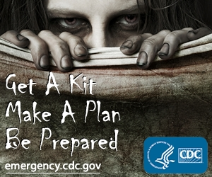

Zombie Apocalypse Poster Cover Your Cough
Available at the Centers Available at Minnesota
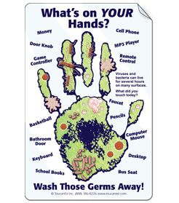
For Disease Control and Prevention Department of Health

What’s on Your Hands?
Available at Toucan Ed

