ORDINANCE NO. 2026-____
AN ORDINANCE CLARIFYING FENCE HEIGHT STANDARDS AND EXEMPTIONS, REMOVING FENCE OPACITY STANDARDS, AND ADDING FENCE COVERING MATERIAL STANDARDS, THEREBY AMENDING CHAPTER 21 OF THE CITY CODE
The City Council of the City of Bloomington, Minnesota ordains:
Section 1. That Chapter 21 of the City Code is hereby amended by deleting those words that are contained in brackets and [stricken through] and adding those words that are underlined, to read as follows:
CHAPTER 21: ZONING AND LAND DEVELOPMENT
***
ARTICLE III: DEVELOPMENT STANDARDS
***
§ 21.301.08 FENCES.
***
(b) Location.
(1) Zoning district. Fences are allowed in any zoning district, subject to the provisions of this code.
(2) Fence location on lot. [Unless otherwise required by this code, fences are permitted up to, but not over the property line.] Fences must maintain a clear view triangle area setback.
(c) Height. Except where otherwise required by this code, the following regulations apply to fence height. For the purposes of fence height requirements, alleys are not considered a street.
(1) Limitations. Except where otherwise required by this code or required by a condition of approval for a development application, the following limitations apply to fence height:

Type of Yard | Maximum Height for Body of Fence
Type of Yard | Residential Use | Nonresidential Use
Yard abutting a street | 4 ft. | 6 ft.
Yard not abutting a street | 6 ft. | 10 ft.

(2) Exceptions and interpretation. The following exceptions and guidance on interpretation apply to fence height limitations:
(A) A residential fence in a yard abutting an arterial street as designated by the Comprehensive Plan may rise to a maximum height of six feet;
(B) Any residential fence may rise to a height of eight feet if the following locational requirements are all met:
(i) The fence must not be located in a front yard or yard abutting a street unless it is set back at least 65 feet from the public right-of-way; and
(ii) Fences located within side or rear yards not abutting a street must meet the required setback from a specific property line for a principal structure in the applicable zoning district;
(C) A residential fence in the side yard or rear yard along a street of a corner lot may rise to a height of six feet when located behind the rear plane of the principal structure to the rear lot line [provided the fence meets the minimum setback from the street for a principal structure in the applicable zoning district or provided the fence is no closer to a street than an existing principal structure or garage];
(D) A residential fence in the rear yard of a through lot when one or more abutting lots are also through lots may rise to a height of six feet;
(E) A residential fence abutting a nonresidential use may rise to the height of eight feet;
(F) Screening fences required by the city code (see subsection (g)(4) below for references);
(G) Screening fences required by a condition of approval for a development application; [and]
(H) Public chain link fences for public safety and/or public research purposes such as along public trails and/or at public parks
(3) Graphic illustration: determining fence height by yard.
Figure 21.301.08(c)(3)
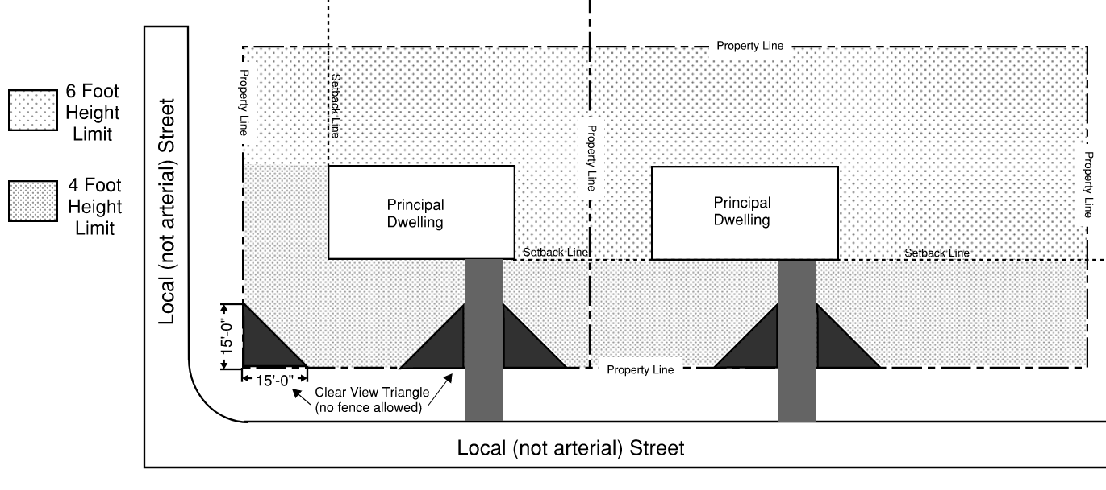

(4[3]) Measurement. Fence height is measured to include the body of the fence, plus allowing a maximum of six inches (on average between posts) above the natural grade (i.e., for drainage purposes). Fence posts are permitted to extend a maximum of 12 inches above the body of the fence. In the event fence height has been elevated through the use of a retaining wall, the creation of a berm or other method for the primary purpose of increasing the elevation of the fence, the fence height is measured from the ground elevation prior to grade modification.
(5[4]) Graphic illustration: measuring fence height.
Figure 21.301.08(c)(5[4])
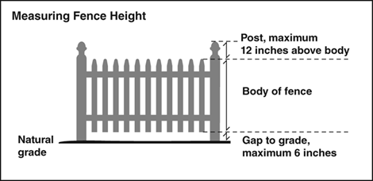
(d) Reserved.[Opacity (the degree of openness to which light or views are blocked measured perpendicular to the fence for each fence section between supports). The following opacity limitations are meant to maintain an open feeling along public streets and to prevent crime.
(1) Limitations. Where the body of a fence in a yard adjacent to a street is over three feet in height and does not meet the required setback for a principal structure from a street in the applicable zoning district, the amount of fence opacity is limited to 50%. For the purposes of fence opacity limitations, an alley is not considered a street.
(2) Exceptions. The following fences are exempt from opacity limitations:
(A) Fences in a yard adjacent to an arterial street as designated by the City Comprehensive Plan provided a 15-foot clear view triangle area is maintained between the intersection of any driveway with a sidewalk or bikeway;
(B) Screening fences required by the city code (see subsection(g)(4) below for references);
(C) Screening fences required by a condition of approval for a development application;
(D) Fences in the rear yard of a through lot when adjacent lots are also through lots;
(E) Fences in the rear yard of a corner lot when the fence is no closer to the street than an existing principal structure or garage; and
(F) Vegetation growing adjacent to or on a fence will not be considered in determining compliance with the opacity requirements for fences.
(3) Graphic illustration: fence opacity.
Figure 21.301.08(d)(3)]
[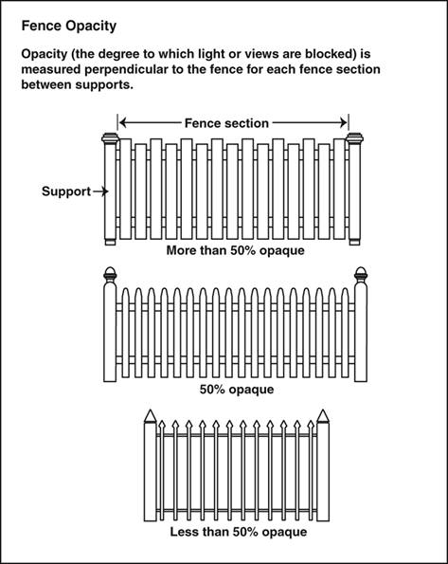]

(e) Materials.
(1) Permitted materials. Fences must be constructed of wood, metal, bricks, masonry, plastic or other materials designed for permanent outdoor fencing. Wood fences must be constructed of cedar, redwood or other decay resistant wood. Chain link fencing of less than 12 gauge in diameter is prohibited (for example, where 13 gauge is finer and not permitted, and 11 gauge is thicker and permitted).
(2) Prohibited materials. Fences must not be constructed from razor wire, snow fencing, plywood or materials originally intended for other purposes. Above ground electric fencing is not permitted. Barbed wire is permitted only on top of fences in nonresidential districts, a minimum of six feet above the natural grade. Electric fencing or barbed wire is permitted for prescribed grazing as set forth in § 14.99(m).
(3) Fence covering material. Any screening material placed upon a chain link fence must be a commercially-built product manufactured specifically for use on fencing. Fence screening material must be securely fastened or attached to the fence itself. Slat devices inserted into a chain link fence do not satisfy screening requirements specified in § 21.301.15(d). The finished side of the fence covering must face outward from the subject property.
(4[1]) Exceptions. The following fences are exempt from material limitations:
***
(f) Restrictions. The following restrictions on fences apply to protect the public health, safety and welfare.
(1) [Ownership. All fences, including fence footings, must be located entirely on the fence owner’s property.
(2)] Public easements. Fences may not be placed on or extend into a public easement where public improvements are located without approval of an encroachment agreement by the Director of Public Works or designee along with proof that the agreement has been filed with the records for the property in the office of the County Recorder or Registrar of Titles. When installing any part of a permitted fence into a public easement, the city or any agent of the city permitted to use the easement will be held harmless for any and all claims for damage to the fence that might occur when work is performed in the easement. In addition, the city is not responsible or liable for the reinstallation of any fence removed from the easement.
(2[3]) Clear view triangle. Fences of any style or material must maintain a clear view triangle area as defined in § 21.601 and shown in Figure 21.301.08(f)(2[3]).
Figure 21.301.08(f)(2[3])
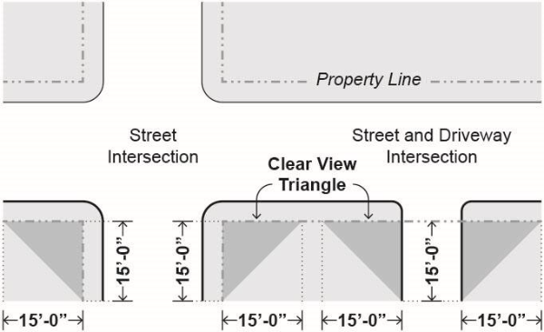
(3[4]) Adjacent to sidewalks. Fences adjacent to public sidewalks must be set back a minimum of two feet from the nearest edge of sidewalk.
(4[5]) Fire hydrant and utility clear zone. The area three feet in radius around all fire hydrants, fire hose connections and utility boxes must be kept free of any fencing that could impede access to or use of the hydrant, fire hose connection or utility box.
(5[6]) Fences in floodways. Fences are not permitted in floodway areas as designated on FEMA’s flood boundary and floodway map.
(6[7]) Drainage. A fence must not adversely affect drainage or create debris build-up.
***
(m) [Other constructed features. The following constructed features are differentiated from fences.
(1) Arbors and trellises. Except where otherwise required in this code, regulations governing fences apply to arbors and trellises used in lieu of a fence or in combination with a fence, except that arbors and trellises used in lieu of a fence may rise once to a maximum height of nine feet for a distance of six feet in length, in compliance with § 21.301.02(g).
(2)] Walls. Except where otherwise required in this code, regulations governing the height and[,] location [and opacity] of fences apply to walls used in lieu of a fence or combination with a fence. Setback requirements apply for walls over four feet tall.
[(n) Effective date. This section will be effective on December 31, 2008.]

Section 2. Effective Date. This Ordinance shall be in full force and effect from and after its passage and publication according to law.

Passed and adopted on March 23, 2026.

______________________________
Mayor

ATTEST: APPROVED:

__________________________ ______________________________
Secretary to the Council City Attorney

