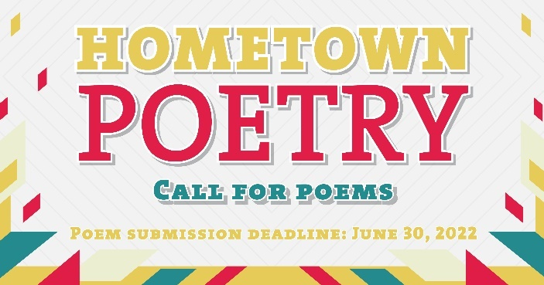

Hometown Poetry – Panel Members

Jessica Anderson – Creative Placemaking Commissioner, Bloomington resident
Jessica has extensive professional experience with large- and small-scale event production, community engagement programs serving various segments of a community, and works effectively on multidisciplinary teams that include residents, public partners, and financial stakeholders. Jessica holds a Master’s in Public Administration, a Bachelors in Recreation Services Management, with a minor in Studio Arts. Her passions include public art, visual and performing arts, and youth initiatives that give access to young residents who deserve a voice as decision makers in their community. She currently serves as a Board Member on Together Bloomington a non-profit focused on improving community civic involvement and promote social, cultural, recreational, and educational opportunities in Bloomington.

Willie James Johnson
Willie James Johnson was born in Detroit, Michigan and grew up on the Southside of Chicago. He holds a B.A. from Hamline University; M.A. and Ph.D. degrees from the University of Minnesota
Since 1982 Willie has been a full-time tenured faculty member in the Communication department at Normandale Community College. In addition, since 2000 he has been an adjunct full professor of Education at St. Mary’s University of Minnesota. He is a former Fulbright Scholar as well as a McKnight Fellow.

He has written extensively for various publication including scholarly journals, newspapers, poetry anthologies, etc.

His travels have included Liberia, Sierra Leone, Senegal, China, Thailand, Belgium, Austria, England, Venezuela, Puerto Rico, Bahamas, Mexico, Canada, and Hawaii.

Willie is the father of three and grandfather of five. He lives in Bloomington, MN. His interests include gardening, cooking, conversations, writing, reading, guitar, singing, biking, and traveling.

Beth McCoy – Creative Placemaking Commissioner, Bloomington resident
A Bloomington resident and veteran teacher with Bloomington Public Schools. I am an Arts Integration Specialist and Master Trainer with Artful Learning. I enjoy art of all kinds and have a passion for educating children and adults using an artful lens. My hobbies include camping, hiking, and kayaking.

Chelley McLear
Chelley McLear is an East Bloomington resident and the On-Site Learning Manager at Artistry. Before arriving in the US five years ago, she was the long-term manager of the Literary and Verbal Arts programs at Community Arts partnership in Belfast, Northern Ireland, the largest of their kind in the region. In that time she edited more than thirty anthologies of public poetry across a number of organizations and curated and managed the Seamus Heaney Awards for New Writing and for Achievement. She has led poetry workshops on four continents and is excited to be involved with this public project in Bloomington - bringing poetry to the streets!

Yariet Montes – Creative Placemaking Commissioner, Bloomington resident
Yariet has experience and background in finance, local government, racial equity, and community organizing. More about Yariet: “My name is Yariet I identify as a Chicanx Indigenous woman. I am a single mom of four children and a full-time student at DeVry University and a part-time student at Metropolitan State University. I love to spend as much time as I can with my family and with Mother Nature. My ancestors believe that nature is sacred, and that Mother Nature heals our soul which makes summer my favorite because I get to walk and connect with Mother Nature when I walk bare foot in my backyard. I get to reconnect with my ancestors when I work in my garden. Apart from that I have many passions and all my passions always connect with one main mission and that is to do my best to create change in the world for our future generation as my ancestors did for me.”

Nicole Payne
Nicole Payne is an avid poet and creative writer. Her poetry is focused on LGBTQ+ experiences and her personal experiences as a transgender woman. She has published work on the Riverwhale Review Magazine as well as live poetry performances at festivals in Minnesota. She is finishing her bachelor's degree at Minnesota State University Mankato with a Major in Psychology and a Minor in Creative Writing and has studied poetry extensively in her courses.

Jamie Schumacher– Creative Placemaking Commissioner, Bloomington resident
Jamie Schumacher traded the warm beaches of California for the snowy lakes of Minnesota, where she found art, community, and more.

By day she works with LISC Twin Cities, working with the Twin Cities cultural districts. By night she’s a visual artist and an accomplished writer. Jamie’s work has been featured in Pollen, Star Tribune, and Minnesota Women’s Press. Her two books It’s Never Going To Work (2018) and Butterflies and Tall Bikes (2021) are narrative nonfictions featuring Minnesota’s creative communities.

Jamie currently lives in Bloomington with her partner Nick, their daughters, a rescue named Rufus, and four chickens. She currently serves on the city of Bloomington's creative placemaking commission.

Logan Sauer – Creative Placemaking Commissioner, Bloomington resident
Logan Sauer is a Park Ranger at Minnesota Valley National Wildlife Refuge located in Bloomington, MN. Originally from Northern Virginia, he went on to study wildlife ecology and anthropology at the University of Maine. He enjoys being outdoors, painting, connecting with the public, and putting on programs that connect people to nature through the arts. While he has not pursued art as a career, he still gets to incorporate it into his work as a Park Ranger and has even managed to share his artistic talents with several other national wildlife refuges across the country. Additionally, he taps into his artistic expertise as he serves on the Creative Placemaking Commission for the City of Bloomington!

